ITEC485

Final Project

Bradberry

**Are Cornoavirus Cases Being Lowered or are Fewer Tests Being Conducted?**

Coronavirus bad. Economic impact bad. Exponential growth. Contagion.

Number of confirmed cases over time. Number of tests conducted over time. Are they similar in scale?

Results. Make a note April 21st lag time, so don’t trust anything after. Mention that null dates before 22nd were coded as zero for data handling purposes.

Here’s my evidence:

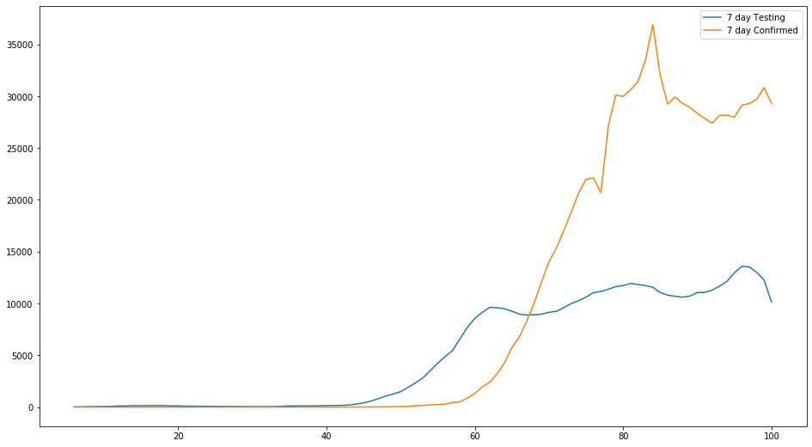

https://www.cdc.gov/coronavirus/2019-ncov/cases-updates/cases-in-us.html